Add/Remove
Account Condition in Bulk

Developed By: Syed Muhammad Abid Raza (27383)
Mustafa Madraswala(27377)
Technical Lead: Mr. Mubashir Abbas, Mr. Mubashir Hassan
Business Analyst: Mr. Zaheer, Mr. Fazal
Project Manager: Mr. Faizan

Objective:

A new screen is required to be introduce for users to add/remove account conditions in bulk.

Roles and Access Rights:
For this project, a single role will be involved of authorizer as only CPU users will use this module.

Activity Flow:
This section will cover the overall flow of the working of this application in the form of a flowchart.

- Login:

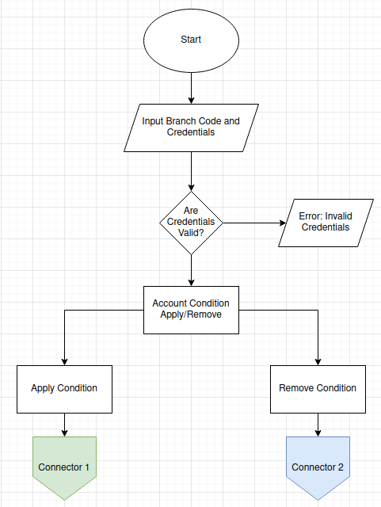

- Apply Condition:

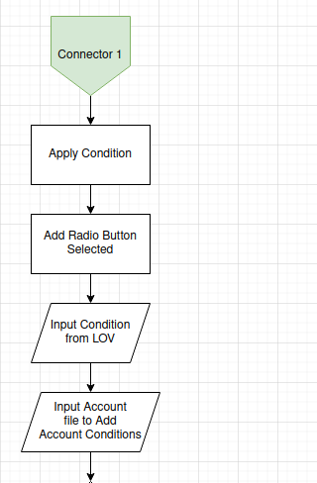
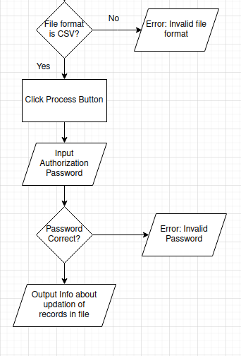

Remove Condition:
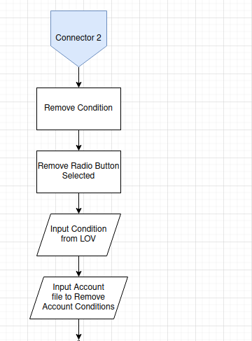
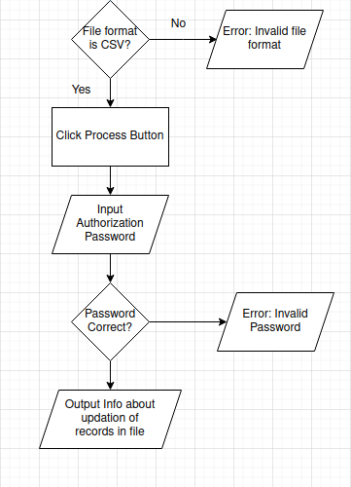
Tech Stack:
- Programming Language
- Back-end: Java
- Front-end: HTML, CSS, JavaScript
- Framework
- Back-end: Quarkus
- Front-end: Vue.js
- Database: IBM DB2
- IDE
- Development: VS Code
- Database: DBeaver

Architecture Design:

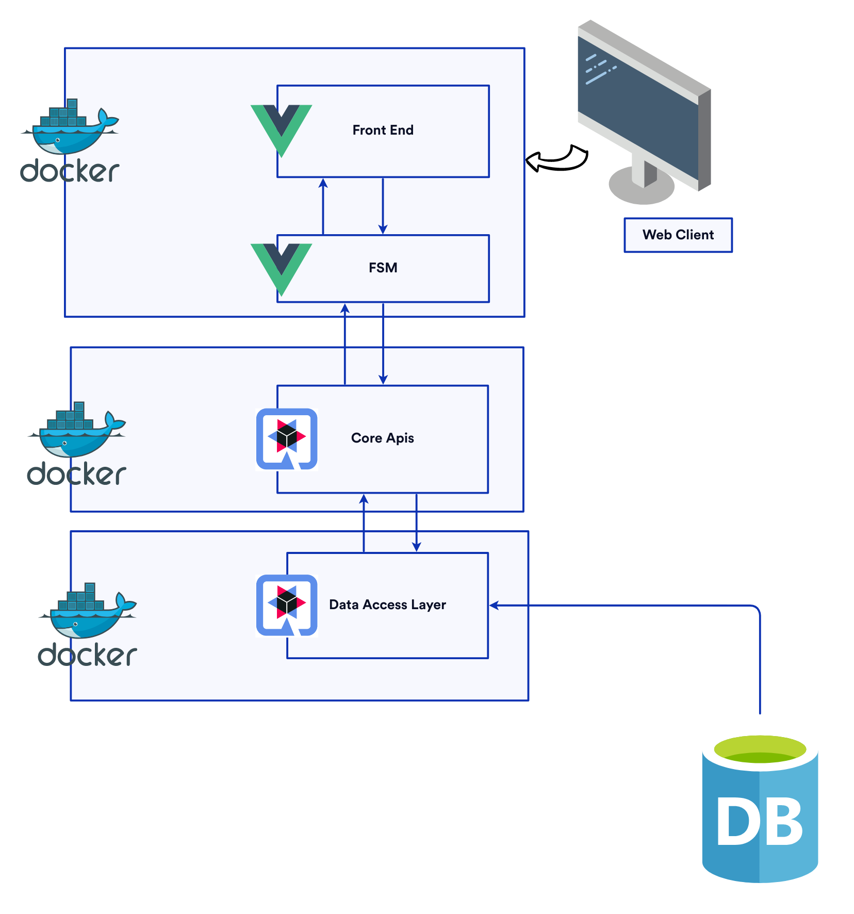

Database Design:

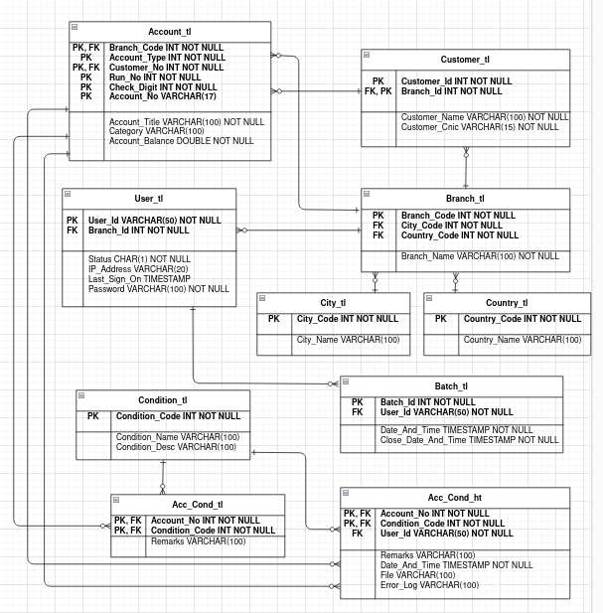

Tables:

Table Name | Name | Column Type | Length | Primary Key | Foreign  Key
Customer_tl | Customer_ID | Int | - | YES | NO
Customer_tl | Branch_ID | Int | - | YES | YES
Customer_tl | Customer_Name | Varchar | 100 | NO | NO
Customer_tl | Customer_CNIC | Varchar | 15 | NO | NO

Table Name | Name | Column Type | Length | Primary Key | Foreign  Key
User_tl | User_ID | Varchar | 50 | YES | NO
User_tl | Branch_ID | Int | - | NO | YES
User_tl | Status | Char | 1 | NO | NO
User_tl | IP_Address | Varchar | 20 | NO | NO
User_tl | last_sign_on | Datetime | - | NO | NO
User_tl | Password | Varchar | 100 | NO | NO

Table Name | Name | Column Type | Length | Primary Key | Foreign  Key
Account_tl | Branch_code | Int | - | YES | YES
Account_tl | Account_Type | Int | - | YES | NO
Account_tl | Customer_No | Int | - | YES | YES
Account_tl | Run_No | Int | - | YES | NO
Account_tl | Check_Digit | Int | - | YES | NO
Account_tl | Account_No | Varchar | 17 | YES | NO
Account_tl | Account_Title | Varchar | 100 | NO | NO
Account_tl | Category | Varchar | 100 | NO | NO
Account_tl | Account_Balance | Double | - | NO | NO

Table Name | Name | Column Type | Length | Primary Key | Foreign  Key
Branch_tl | Branch_code | Int | - | YES | NO
Branch_tl | City_Code | Int | - | NO | YES
Branch_tl | Country_Code | Int | - | NO | YES
Branch_tl | Branch_Name | Varchar | 100 | NO | NO

Table Name | Name | Column Type | Length | Primary Key | Foreign  Key
City_tl | City_Code | Int | - | YES | NO
City_tl | City_Name | Varchar | 100 | NO | NO

Table Name | Name | Column Type | Length | Primary Key | Foreign  Key
Country_tl | Country_Code | Int | - | YES | NO
Country_tl | Country_Name | Varchar | 100 | NO | NO

Table Name | Name | Column Type | Length | Primary Key | Foreign  Key
Condition_tl | Condition_Code | Int | - | YES | NO
Condition_tl | Condition_Name | Varchar | 100 | NO | NO
Condition_tl | Condition_Desc | Varchar | 100 | NO | NO

Table Name | Name | Column Type | Length | Primary Key | Foreign  Key
Batch_tl | Batch_Id | Int | - | YES | NO
Batch_tl | User_Id | Varchar | 50 | NO | YES
Batch_tl | Date_And_Time | Timestamp | - | NO | NO
Batch_tl | Close_Date_And_Time | Timestamp | - | NO | NO

Table Name | Name | Column Type | Length | Primary Key | Foreign  Key
Acc_Cond_tl | Account_No | Int | - | YES | YES
Acc_Cond_tl | Condition_Code | Int | - | YES | YES
Acc_Cond_tl | Remarks | Varchar | 100 | NO | NO

Table Name | Name | Column Type | Length | Primary Key | Foreign  Key
Acc_Cond_ht | Account_No | Int | - | YES | YES
Acc_Cond_ht | Condition_Code | Int | - | YES | YES
Acc_Cond_ht | User_Id | Varchar | 50 | NO | YES
Acc_Cond_ht | Remarks | Varchar | 100 | NO | NO
Acc_Cond_ht | Date_And_Time | Timestamp | - | NO | NO
Acc_Cond_ht | File_Of_Accounts | Varchar | 100 | NO | NO
Acc_Cond_ht | Error_Log | Varchar | 100 | NO | NO

